**CURRICULUM VITAE**

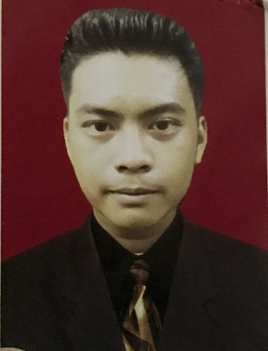**PERSONAL DETAIL**

Name : Philivescu Alessandro R.J.A

Place date of birth : Depok, 03 July 2000

Gender : Male

Marital Status : Single

Religion : Islam

Nationality : Indonesian

Address : Apartement Bassura City Tower H, Kp. Melayu Cipinang besar, Jakarta Timur.

Phone : 085782652485

E-mail : Alessandroaponno03@gmail.com

**Education Details:**

**1.** 2006-2012 SDN 05 Lebak Bulus Jakarta

**2.** 2012-2015 Mts Miftahul Umam Jakarta

**3.** 2015-2018 SMK NEGERI 57 Jakarta

**Job Experiences:**

1. Trainee Housekeeping **(JW Marriot Jakarta)**
2. DW Banquet **(Kempinski Hotel Indonesia)**
3. Waiters **(Kobeshi by Shabu 2 House)**
4. DW Housekeeping **(Gran Melia Hotel Jakarta)**
5. DW Laundry Attendant **(Gran Melia Hotel Jakarta)** Until now .